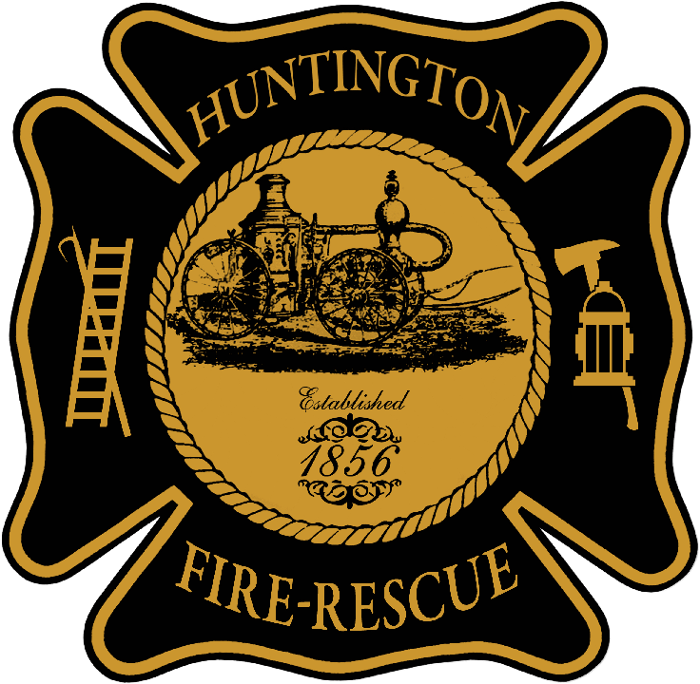

City of Huntington Fire Department

747 Condit St.

Huntington, Indiana 46750

260-356-3620

**Huntington City Ordinance**

**94.10 OPEN BURNING**

No one shall kindle or maintain any open burning (which means any burning of combustible materials out of doors) within the corporate limits of the city except as follows, and then only in a situation where it is reasonably unlikely that the open burning may be spread to or damage other property, or that the smoke and/or fumes emissions would be a nuisance to persons upon adjacent property.

(1) Exemptions

(a) Recreational campfires with a total fuel area no greater than 36 inches in diameter and a fuel load not to exceed two vertical feet.

(1) Recreational campfires shall be located a safe distance from structures, fences, and public rights-of-way, and attended at all times until completely extinguished. There shall be a garden hose or better connected to a water supply source and/or buckets, shovels, fire extinguishers, or other adequate fire extinguishing equipment readily available.

(b) A reasonably sized and located barbecue pit or grill where either electricity, gas, wood, or charcoal is used for the preparation of food.

Fires which burn substantial quantities of leaves, paper, garbage, rubbish, grass, trade waste, plastics, or other similar items, are prohibited.

Any person who knowingly or who intentionally kindles or maintains any open burning in violation of this section shall be subject to the penalties hereunder.