FACILITY | LAT/LONG | EMERGENCY CONTACTS | PLAN LOCATION | ALARM | EQUIPMENT | TRAINING
Echo Lake Foods Inc 435 W State St Huntington In 46750 | N 40.8801  W -85.4974 | P-Todd Fowler  260-242-6588  S-Russ Kennedy  262-716-8453 | Security Office | Yes | Spill Kit | Company  Training  1-Tech  2-Operations
Ecolab Inc Huntington Distrib Ctr 68 Commercial Dr  Huntington In 46750 | N 40.8946  W -85.5205 | P-Shelly Swain  260-672-9006  S-Rhonda Bennett  260-341-0277 | Security Office | None | Spill Kit | Company Training  1-Tech  2-Operations
Ecolab Inc  970 E Tipton Sst Huntington In 46750 | N 40.890874  W -85.491069 | P-Bob Ratliff  765-661-4927  S-Eric Bricker  678-656-8185 | Security Office | None | Spill Kit | Company  Training  1-Tech  2-Operations
Frontier Communications 650 Commercial St. Roanoke In 46783 | N 38.663328  W -87.169412 | P-Bryan Andrus  800-590-6605  S-Jason Weller  800-590-6605 | Central Operations | None | Spill Kit | Company Training  1-Operations
Gladieux Trading & Marketing  4757 N US 24  Huntington In 46750 | N 40.5354  W -85.2653 | P-Dennis Livingston  260-417-1116  S-Ron Moore  260-417-0105 | Facility Office | None | Spill Kit | Hazwoper  Training  3-Tech  3-Operations
Ground Effects LLC 13204 Aboite Rd  Roanoke In 46783 | N 40.9639  W -85.3196 | P-Paul Witbrodt  260-249-9390  S-Greg Morphew  260-750-1856 | Facility Office | None | None | Company Training  1-Operations
Helena Chemical Co. 321 Thurman Poe Way Huntington In 46750 | N 40.895538  W -85.445469 | P-Jason Warnock  260-571-3654  S-Terry Drottz  260-504-0010 | Facility Office | Yes | Spill Kit | Hazwoper  Training  2-Tech  2-Operations
Huntington Sheet Metal 1675 Riverfork Dr  Huntington In 46750 | N 40.866364  W -85.523792 | P-Brice Kaylor  260-356-9011 Ext 235  S-Matt Sutter  260-356-9011 Ext 273 | Facility Office | None | None | Company  Training  1-Tech  1-Operations
Huntington South Water Plant  2290 Engle St  Huntington In 46750 | N 40.8555  W -85.4989 | P-Matthew Hosier  260-409-5902  S-Mike Plasterer  260-417-2268 | Facility Office | None | Spill Kit | Company  Training  1-Tech  1-Operations

FACILITY | LAT/LONG | EMERGENCY CONTACTS | PLAN LOCATION | ALARM | EQUIPMENT | TRAINING
Huntington Water WPC 20 Hitzfield St  Huntington In 46750 | N 40.872371  W -85.514927 | P-Matthew Hosier  260-409-5902  S-Mike Plasterer  260-417-2268 | Facility Office | None | Spill Kit | Company  Training  1-Tech  1-Operations
Indiana-Michigan Power Sorensen Station  5711 E CR 1100 N  Roanoke In 46783 | N 40.984162  W -85.342648 | P-Brian Miller  614-413-4353  S-Michael Nowatzke  419-348-8961 | Central Operations | None | Spill Kit | Company  Training  1-Operations
Koch Fertilizer LLC 502 E Hosier Rd Huntington In 46750 | N 40.893611  W -85.443889 | P-Pipeline Control Ctr  800-666-9042  S-Tom Miller  260-452-3209 | Facility Office | Yes | HazMat | Hazwoper  Training  3-Tech
Our Sunday Visitor 200 Noll Plaza  Huntington In 46750 | N 40.891155  W -85.484923 | P-George Pape  260-359-2561  S-Tim Shoup  260-438-3636 | Facility Office | None | None | Company  Training  1-Tech  2-Operations
Nutrien Ag Solutions  423 E CR 1000 S  Warren In 46792 | N 40.682555  W -85.469839 | P-Robert Kelly  260-824-5753  S-Rich Clark  260-402-0512 | Facility Office | Yes | Spill Kits | Hazwoper  Training  1-Tech  2-Operations
Schneider Electric 6 Commercial Rd  Huntington In 46750 | N 40.889919  W -85.523995 | P-Todd Scheumann  260-433-7575  S-Jim Harden  260-388-1496 | Facility Office | None | None | Company  Training  1-Tech  1-Operations
United Technologies Controls Inc  3650 W 200 N  Huntington In46750 | N 40.85924  W -85.524635 | P-Jennifer Jenkins  260-615-6126  S-Stephen Morin  207-245-0615 | Facility Office | None | Spill Kit | Company  Training  1-Tech  1-Operations
28 EHS Facilities

IV. DOCUMENTATION AND INVESTIGATIVE FOLLOW-UP

Level I Hazardous Materials Incident
  - In case of a Level I Hazardous Materials incident, the spiller must submit to the LEPC a brief description of the incident and the response rendered. Where the spill exceeded the reporting requirements, the IC must ascertain that the spiller has notified the appropriate State and Federal agencies, as required.
  - The CEC, or his designee, will maintain a log of all Hazardous Materials incidents reported to the Huntington County LEPC on a calendar year basis.

Level II and Level III Hazardous Materials Incidents
  - The CEC, or his designee, is responsible for ensuring a report is prepared and provided to the LEPC if the spill is regulated and over a reportable quantity. The report should summarize the entire incident, including:
    - Cause of the incident
    - Damage assessment
    - Agencies involved
    - Actual cost of response activities (if known)
    - Incident critique
    - Conclusions
  - To assist with the completion of this report, Huntington County Dispatch and the Incident Commander are responsible for documenting the communications between the ICP, the 9-1-1 dispatcher, and all response agencies involved. This documentation must include location, the material and quantity of chemical released, the owner or operator involved, the source of spill, health or physical hazards generated, and response activities. For incidents occurring in a fixed facility, the owner or operator is required to submit a follow- up report to the local LEPC, as well as the appropriate State and Federal agencies.
  - The Huntington County EMA Director will consolidate all billings and will assist the LEPC, as needed, in preparing the investigative report in order to facilitate any cost recovery. Any criminal investigations, if required, will be the responsibility of the jurisdictional law enforcement agency where the incident occurred.

Tab 6 - Telephone Numbers (Radio/TV)

MEDIA | PHONE | FAX
Huntington Herald Press  7 N. Jefferson ST  Huntington In 46750 | Linda Kelsay  260-563-2131 | 260-563-0816
Huntington County TAB  1670 Etna Ave  Huntington In 46750 | Steve Clark  260-982-6383 | 260-982-8233
The Paper of Wabash County  SR13N  Wabash IN 46992 | Joseph Slacian  260-563-8326 | 260-563-2863
Marion Chronicle-Tribune  610 S Adams Street  Marion IN 46952 | Andrew Maciejewski  765-664-5111  800-955-7888 | 765-668-4256
Fort Wayne Journal Gazette  600 W Main Street Fort Wayne IN 46801 | Sherry Skufca  260-461-8773  800-324-0505 | 260-461-8648
WKUZ Radio 95.9FM  1864 S Wabash Street Wabash IN 46992 | Charles Adams  260-563-4111  569-9590(Unlisted) | 260-563-4425
WJOT Radio 105.9FM  1360 S Wabash Street Wabash IN 46992 | Unknown  260-563-1161  866-563-1161 | 260-563-0883
WXXC Radio 106.9 FM WBAT Radio 1400AM WCJC Radio 99.3FM  820 S Pennsylvania Street  Marion IN 46952 | Joel Pyle  765-664-7396  765-664-6239 | 765-668-6767  765-662-0730
WOWO Radio 1190AM  2915 Maples Road Fort Wayne IN 46816 | Mike Ragz  260-447-5511  260-447-6397 | 260-447-7546
WFFT Fox 55  3707 Hillegas Road Fort Wayne In 46808 | Fred Brunell  260-471-5555  260-408-9338 newsroom | 260-484-4331
WPTA TV (ABC) - Channel 21 WKJG TV (NBC) - Channel 33  3401 Butler Road  Fort Wayne IN 46808 | Brien McElhatten  260-483-8111 | 260-483-0584
WANE TV (CBS) – Channel 15  2915 W State Blvd Fort Wayne IN 46808 | Pat Hoffmann  260-422-5644 | 260-484-8240
WISH TV (CBS) - Channel 8 1950 N Meridian Street Indianapolis IN 46202 | Unknown  317-931-2222 | 317-931-2242
WRTV TV (ABC) – Channel 6 1330 N Meridian Street Indianapolis IN 46202 | Unknown  317-635-9788 | 317-269-1445
WTHR TV (NBC) – Channel 13  1000 N Meridian Street Indianapolis IN 46204 | Unknown  317-655-5740  317-636-1313 | 317-655-5984

V. TRAINING AND EXERCISES

Training
Training will be based upon the duties and functions to be performed by each responder of an emergency response organization. The skill and knowledge levels required for all new responders, those hired after the effective date of this Plan, shall be conveyed to them through training before they are permitted to take part in actual emergency operations of a Hazardous Materials incident. Responders who participate in a chemical emergency shall be given training in accordance with the following:
  - First Responder – Awareness Level. Responders at the awareness level are individuals who are likely to witness or discover a hazardous substance release and who have been trained to initiate an emergency response sequence by notifying the proper authorities of the release. They would take no further actions beyond notifying the Huntington County Dispatch Center of the release. First responders at the awareness level shall have sufficient training or had sufficient experience to objectively demonstrate competency in the following areas:
    - An understanding of what hazardous materials are, and the risks associated with them.
    - An understanding of the potential outcomes of an emergency where hazardous materials are present.
    - The ability to identify the hazardous materials, if possible.
    - An understanding of the role of the awareness level first responder in the department’s Emergency Response Plan and the ERG.
    - The ability to recognize the need for additional resources.
  - First Responder – Operations Level. First responders at the operations level are individuals who respond to releases or potential releases of hazardous substances as part of the initial response to the site for the purpose of protecting nearby persons, property, or the environment from the effects of the release. They are trained to respond in a defensive fashion without actually trying to stop the release. Their function is to contain the release from a safe distance, keep it from spreading, and prevent exposure. First responders at the operations level shall have received at least eight (8) additional hours of training and be certified by the State of Indiana. They shall have had sufficient experience to objectively demonstrate competency in the following areas in addition to those listed for the awareness level. The responder’s department shall certify responders trained at the operations level have:
    - Knowledge of the basic hazard and risk assessment techniques.
    - The ability to select and use proper personal protective equipment (PPE) provided to the first responder- operations level.
    - An understanding of the basic Hazardous Materials terms.
    - The ability to perform basic control, containment, and/or confinement operations within the capabilities of the resources and PPE available with their department.
    - The knowledge to implement basic decontamination procedures.
    - An understanding of the relevant SOPs.

  - Incident Commander – ICS System. Incident Commanders, who will assume control of the incident scene beyond the first responder-awareness level, shall receive training equal to the operations level. The responder’s department shall certify competency in the following areas:
    - Know and be able to implement the department’s ICS system in accordance with NIMS.
    - Know and be able to implement the department’s SOPs for Hazardous Materials incidents.
    - Know and understand the hazards and the risks associated with responders working in chemical personal protective clothing (PPE).
    - Know and understand the importance of decontamination procedures.
  - Refresher Training. Those responders who are trained in accordance with 29-CFR 1910.120, shall receive annual refresher training of sufficient content and duration to maintain their competency, and if a statement of competency is made, the appropriate department shall maintain a record of the methodology used to demonstrate the competency.

Exercises
The Huntington County LEPC Chairman in coordination with the Huntington County EMA Director will contract for and/or design in-house a hazardous material exercises to include, scheduling, and evaluating exercises and drills. All signatory agencies shall participate in periodic Hazardous Materials drills and exercises. At least one annual Hazardous Materials exercise (tabletop, functional, or full-scale) shall be conducted in accordance with IERC annual guidelines. Each exercise shall be followed by a critique to review the effectiveness of this Plan and its support systems. This Plan shall be revised on the basis of the exercise After Action Report and Hot Wash critiques.

VI. ANNEX MAINTENANCE
The Huntington County LEPC, with the support of the county’s Chief Executives and the EMA Director, are responsible for the review and update of this Hazardous Materials Emergency Response Plan. This plan shall be updated at least annually under the direction of the LEPC and submitted to the IERC for review. Appendices of this Plan may be updated more frequently.
VII. AUTHORITIES AND REFERENCES

Authorities
  - 40 CFR Part 301, Reimbursement to Local Governments for Emergency Response to Hazardous Substance Releases
  - 40 CFR Part 302, Comprehensive Environmental Response Compensation and Liability Act (CERCLA) List of 717 Substances
  - 40 CFR Part 310, Reimbursement to Local Governments for Emergency Response to Hazardous Substance Releases, Interim Final Rule
  - 40 CFR Part 355 and Appendix A, List of 406 Extremely Hazardous Substances
  - 40 CFR Part 370, Hazardous Chemical Reporting: Community Right-to-Know, Tier I and Tier II Forms, Chemical Inventory Reporting
  - 40 CFR Part 372, Toxic Chemical List, Toxic Chemical Release Reporting: Community Right to Know
  - CERCLA of 1980 (Public Law 96-510)
  - Huntington County Emergency Management Ordinance
  - Huntington County Comprehensive Emergency Management Plan (CEMP)
  - Emergency Management and Assistance (44 US Code 2.1)
  - Governor’s Executive Order 05-09
  - Indiana Code Title 10-14-3-17
  - Local Mutual Aid Agreements
  - Title III, Federal Emergency Planning and Community Right to Know of the Superfund Amendments and Reauthorization Act (SARA) of 1986 (Public Law 99.499)

References
  - FEMA Hazardous Materials Contingency Planning Course
  - Hazardous Materials Exercise Evaluation Methodology (HM-EEM)
  - Homeland Security Exercise and Evaluation Program (HSEEP)
  - National Response Team Hazardous Materials Emergency Response Planning Guide
  - Technical Guidance for Hazardous Analysis Emergency Planning for Extremely Hazardous Substances
  - United States DOT Emergency Response Guidebook

VIII. ACRONYMS AND ABBREVIATIONS

Acronym | Terminology
CAS | Chemical Abstracts Service (division of American Chemical Society)
CEC | Community Emergency Coordinator
CEMP | Comprehensive Emergency Management Plan
CERCLA | Comprehensive Environmental Response, Compensation, and Liability Act
CFR | Code of Federal Regulations
CSEPP | Chemical Stockpile Emergency Preparedness Program
DFBS | Department of Fire and Building Services
DOT | Department of Transportation
EAS | Emergency Alert System (formerly the Emergency Broadcast System)
EHS | Extremely Hazardous Substance
EMA | Emergency Management Agency
EMAC | Emergency Management Assistance Compact
EMS | Emergency Medical Service
EOC | Emergency Operations Center
EOD | Explosive Ordinance Disposal
EOP | Emergency Operations Plan
EPA | U.S. Environmental Protection Agency
EPCRA | Emergency Planning and Community Right-to-Know Act
EPI | Emergency Public Information
ERG | Emergency Response Guidebook
ESF | Emergency Support Function
FBI | Federal Bureau of Investigation
FCO | Federal Coordinating Officer
FEC | Facility Emergency Coordinator
FEMA | Federal Emergency Management Agency
GIS | Geographic Information System
HAZMAT | Hazardous Materials
HAZWOPER | Hazardous Waste Operations and Emergency Response
HC EMA | Huntington County Emergency Management and Homeland Security Agency
HC LEPC | Huntington County Local Emergency Planning Committee
HM-EEM | Hazardous Materials Exercise Evaluation Program
HSEEP | Homeland Security Exercise and Evaluation Program
HSPD | Homeland Security Presidential Directive
IAP | Incident Action Plan
IC | Incident Commander
ICP | Incident Command Post
ICS | Incident Command System
IDEM | Indiana Department of Environmental Management
IDHS | Indiana Department of Homeland Security
IERC | Indiana Emergency Response Commission
IPAWS | Integrated Public Alert & Warning System
LEPC | Local Emergency Planning Committee
MOA | Memorandum of Agreement

Acronym | Terminology
MOU | Memorandum of Understanding
MSDS | Material Safety Data Sheet
NFPA | National Fire Protection Association
NIMS | National Incident Management System
NIOSH | National Institute for Occupational Safety and Health
NRC | National Response Center/Nuclear Regulatory Commission
NRF | National Response Framework
NRP | National Response Plan
NRT-1 | National Response Team
NWS | National Weather Service
OSC | On-Scene Coordinator
OSHA | Occupational Safety and Health Administration
PIO | Public Information Officer
POC | Point of Contact
PPE | Personal Protective Equipment
PRP | Potentially Responsible Party
SARA | Superfund Amendments and Reauthorization Act of 1986 (EPCRA)
SERC | State Emergency Response Committee
SCBA | Self-Contained Breathing Apparatus
SOG | Standard Operating Guideline
SOP | Standard Operating Procedure
UAC | Unified Area Command
UC | Unified Command
UCS | Unified Command System

GLOSSARY OF TERMS/DEFINITIONS
Chemical Emergency Stockpile Emergency Preparedness Program (CSEPP) – A program developed by the EPA to address accidental releases of acutely toxic chemicals.
Community Emergency Coordinator (CEC) - Governmental official with the responsibility of making the determinations necessary to implement county Hazardous Materials Emergency Response Plans. This person is normally the Emergency Management Agency Director or hazardous materials trained LEPC member.
Comprehensive Emergency Management Plan (CEMP) - The “steady-state” plan maintained by various jurisdictional levels for responding to a wide variety of potential hazards.
Comprehensive Environmental Response, Compensation and Liability Act (CERCLA) – A law regarding hazardous substance releases into the environment and the clean-up of inactive hazardous waste disposal sites (i.e., Superfund sites).
Consequence Management - Measures to alleviate the damage, loss, hardship, or suffering caused by emergencies. It includes measures to restore essential government service, protect public health and safety, and provide emergency relief to affected governments, businesses, and individuals. Federal agencies support local response efforts under the coordination of the FEMA.
Crisis Management - Measures to resolve the hostile situation, investigate, and prepare a criminal case for prosecution under federal law. Crisis management response is under the primary jurisdiction of the federal government with the FBI acting as the lead agency.
Critical Facilities - Facilities essential to emergency response, such as fire stations, police stations, hospitals, and communications centers.
Decontamination - The process of making any person, object, or area safe by absorbing, destroying, neutralizing, making harmless, or removing the hazardous material.
Emergency Alerting System (EAS) - Formerly the Emergency Broadcasting System (EBS), the EAS is used to inform the public about the nature of an emergency incident and what safety steps they should take.
Emergency - A situation which poses a threat to the safety of workers, residents, the environment, and/or property.
Emergency Operations Center (EOC) - The physical location at which the coordination of information and resources to support domestic incident management activities normally takes place. An EOC may be a temporary facility or may be located in a more central or permanently established facility, perhaps at a higher level of organization within a jurisdiction. The EOC may be organized by major functional disciplines (e.g. fire, law enforcement, and medical services), by jurisdiction (e.g., Federal, State, regional, county, city, tribal), or some combination thereof.

Emergency Planning and Community Right-to-Know Act (EPCRA) - Title III of the Superfund Amendments and Reauthorization Act of 1986, 42 U.S.C. s. 11001, et seq often referred to as SARA Title III. The EPCRA specifies requirements for organizing the planning process at the State and local levels; minimum plan content; requirements for fixed facility owners and operators to inform officials about EHSs present at facilities; and mechanisms for making information about extremely hazardous substances available to citizens. Facilities that use, produce, or store extremely hazardous substances or hazardous chemicals may fall under the reporting requirements of EPCRA. Facilities must report their chemical inventories if those inventories meet or exceed the listed threshold planning quantity for an EHS or if 10,000 pounds of a hazardous chemical that requires the facility to maintain a Material Safety Data Sheet (MSDS) is present.
Exclusion Zone - The area that immediately surrounds a hazardous material or a nuclear, chemical, or biological release or spill. This is the innermost of the three Hazardous Materials control zones and is also known as the hot zone.
Exercise - A simulated accident or release set up to test emergency response methods and for use as a training tool.
Extremely Hazardous Substance (EHS) - Those chemicals identified by the US EPA on the basis of toxicity and listed under EPCRA, Section 302.
Facility - Defined in Section 302 of EPCRA as all property (e.g., field or grove), buildings, equipment, structures, and other stationary items which are located on a single site or on contiguous or adjacent sites and which are owned or operated by the same person (or by any person which controls, is controlled by, or under common control with, such person) and where the threshold planning quantity or greater of one or more extremely hazardous substances exists. For purposes of emergency release notification, the term includes motor vehicles, transported loads, and aircraft.
Hazardous Material (Haz Mat) - Any substance or material in a quantity or form which may be harmful to humans, animals, crops, water systems, or other elements of the environment if accidentally released. Hazardous materials include: explosives, petroleum, gases (compressed, liquefied, or dissolved), flammable and combustible liquids, flammable solids or substances, oxidizing substances, poisonous and infectious substances, radioactive materials, and corrosives.
Hot Zone – Area where hazardous vapors and liquids are present. This area is considered to be dangerous due to biological, chemical, or nuclear contamination. Individuals must be trained and prepared to enter and leave the area through specific corridors. This is also known as the exclusion zone.
Incident Commander (IC) - The pre-designated local, State, or Federal official responsible for the coordination of hazardous materials response actions, as outlined in the pertinent emergency response plan.
Incident Command Post (ICP) - Facility located at a safe distance upwind from an accident site, where the on-scene commander, responders, and technical representatives can make response decisions, deploy manpower and equipment, maintain liaison with media, and handle communications.
Incident Command System (ICS) - The combination of facilities, equipment, personnel, procedures, and communications operating within a common organizational structure and having the responsibility for management of assigned resources to effectively accomplish stated objectives at the scene of an incident as mandated by OSHA.

Integrated Public Alerting & Warning System (IPAWS) A FEMA developed warning system for wireless (cell) phones that can be used nationally and locally to warn of local, regional or national emergencies or disaster conditions that may or have occurred in a specific areas.
National Incident Management System (NIMS) - The system mandated by the Homeland Security Presidential Directive (HSPD)-5 and (HSPD-7) that provides a consistent nationwide approach for Federal, State, local, and tribal governments; the private-sector, and nongovernmental organizations to work effectively and efficiently together to prepare for, respond to, and recover from domestic incidents, regardless of cause, size, or complexity. To provide for interoperability and compatibility among Federal, State, local and tribal capabilities, the NIMS includes a core set of concepts, principles, and terminology. Homeland Security Presidential Directive-5 identifies these items as the ICS, multi-agency coordination systems; training; identification and management of resources (including systems for classifying types of resources); qualification and certification; and the collection, tracking, and reporting of incident information and incident resources.
National Response Framework (NRF) The purpose of the NRF is to establish a comprehensive, natural, all-hazards approach to domestic incident response by establishing an overview of key response principles, roles, and structures to guide the national response. Designed as a follow-on to the initial National Response Plan, which was actually a “framework” written to guide the integration of State, tribal, and Federal response efforts. Adopting the word “framework” within the title now actually aligns the former NRP document with its intended purpose. It has been written for senior elected and appointed leaders at all levels of government - those who have a responsibility to provide for effective incident management. At the same time, it is designed to inform emergency management practitioners, explaining the operating structures and tools used routinely by first responders and emergency managers at all levels of government.
National Response Plan (NRP) - The former plan mandated by HSPD-5 that integrated Federal domestic prevention, preparedness, response, and recovery plans into on all-discipline, all-hazard plan. This Plan was replaced in 2008 by the National Response Framework.
Protection Level A - The highest available level of respiratory, skin, splash, and eye protection which requires fully encapsulating vapor protective clothing with supplied breathing air. A level A Hazardous Materials release has a high vapor pressure and is toxic through skin absorption or is carcinogenic.
Protection Level B - The level of protective equipment where the environment is not considered acutely vapor toxic to skin but may cause respiratory effects. In such situations, a chemical splash suit or full coverage, non-air tight, chemical suit with self-contained breathing apparatus (SCBA) or supplied air breathing apparatus (SABA) is required.
Protection Level C - The level of protective equipment required to prevent respiratory exposure but not to include possible skin contact (i.e., chemical splash suit with cartridge respirator).
Protection Level D - The level of protective equipment required when the atmosphere contains no known hazard, when splashes, immersions, inhalation, or contact with hazardous levels of any chemical is precluded. Work uniform such as coveralls, boots, leather gloves, and hard hat are used for such situations.
Risk - A measure of the probability of damage to life, property, and/or the environment will occur if a hazard manifests itself; this measure includes the severity of anticipated consequences to people.
Risk Analysis - Assessment of the probable damage that may be caused to the community by a hazardous substance release.

Special Populations - Groups of people that may be more susceptible than the general population (due to preexisting health conditions [e.g., asthmatics] or age [e.g., infants and the elderly]) to the toxic effects of an accidental release.
Unified Area Command - An organization established (1) to oversee the management of multiple incidents that are each being handled by an ICS organization or (2) to oversee the management of large or multiple incident to which several Incident Management Teams have been assigned. Area Command has the responsibility to set overall strategy and priorities, allocate critical resources according to priorities, ensure that incidents are properly managed, and ensure that objectives are met and strategies followed. Area Command becomes Unified Area Command when incidents are multi-jurisdictional. Area Command may be established at an EOC facility or at some location other than an ICP.
Unified Command (UC) - An application of ICS used when there is more than one agency with incident jurisdiction or when incidents cross political jurisdictions. Agencies work together through the designed members of the UC, often the senior person from each agency and/or discipline will participate in the UC, to establish a common set of objectives and strategies and a single Incident Action Plan (IAP).
Vulnerability Analysis - Assessment of elements in the community that are subject to damage should a hazardous materials release occur; includes gathering information on the extent of the vulnerable zone; conditions that influence the zone; size and type of the population within the zone; private and public property that might be damaged; and the environment that might be affected.

X. APPENDICES

TAB 1 - Huntington County Primary Response Agencies/Hazardous Materials Responders TAB 2 - Police, Fire, and Ambulance Locations
TAB 3 - Transportation, Railroad, and Pipeline Routes
TAB 4 - EHS and Non-EHS Fixed Facilities – Vulnerability Zones and Evacuation Routes TAB 5 - EHS Fixed Facilities Information
TAB 6 - Non – EHS Fixed Facilities
TAB 7 - Training and Exercise Program/Schedule
TAB 8 - Telephone Numbers (Radio/TV/Federal/State/Local)
TAB 9 - Population Protection Information (Shelter-in-Place and Evacuation) TAB 10 - Exercise Evaluation Forms/Checklists
TAB 11 - Public Address Announcement (Scripts)
TAB 12 - Huntington County LEPC By-Laws and Membership Roster TAB 13 - County and Township Contacts/Population Information TAB 14 - Chemical Emergency Notification Report
TAB 15 - Resource List
TAB 16 - Hazardous Material Decision Event Trees
TAB 17 - Wellhead Protection Maps of Huntington County Cities and Towns

TAB 1 - HUNTINGTON COUNTY HAZARDOUS MATERIALS
PRIMARY RESPONSE CONTRACTORS

Huntington County does not have a Hazardous Materials team with the primary responsibility to respond to hazardous material incidents. Consequently, mutual aid assistance will be requested through the EOC usually resulting in a delayed response time as a Hazardous Materials team will be responding from the Fort Wayne or Grissom ARB (Peru, Indiana) area. Commercial responders who are capable of environmental assistance with hazardous material clean up are listed below.

CONTRACT HAZARDOUS MATERIALS COMPANIES

Environmental Remediation Services, Inc.
8450 W. Washington Street Indianapolis IN 46231
(260)-489-7062 (24 hour) Ft Wayne Cell (260)-402-4370 Lynn Partridge (317)-247-6119 (24-hour) Indianapolis Cell (260)-402-7994 Roger Boggs Email: www.ersinc.net

Heritage Remediation Kim Reiff And Sons
7901 W. Morris Street 2323 N. Binkley Road
Indianapolis IN 46231 Larwill, In 46764

(317)-243-7475 (260)-327-3134

Hoosier Equipment Services Spill Recovery of Indiana
8014 W. Thompson Road 510 S. Park Drive
Indianapolis IN 46241 Mooresville, Indiana 46158

(317)-856-2751 (317)-831-1971

Specialty Systems 302 South State Street Indianapolis IN 46201

(317)-269-2101

Spill Recovery of Indiana 510 S. Park Drive Indianapolis IN

(800)-421-7764 (24-hour)

TAB 2 - POLICE, FIRE, AND AMBULANCE LOCATIONS

County Law Enforcement Offices County Fire Departments Locations

Huntington County Sheriff’s Department 332 E. State Street  Huntington, IN 46750  260- 356-2520  Chris Newton-Sheriff  Chad Hammel-Chief Deputy | Andrews Volunteer Fire Department (Dallas Township)  796 North Main Street Andrews, IN 46702 Chief Tom Wuensch 260-786-1866
Huntington Police Department 300 Cherry Street  Huntington, IN 46750  260-358-2308  Chad Hacker-Chief | Bippus Volunteer Fire Department 8227 N 900 W  Bippus, IN 46713 Chief Dave Schnitz  260-344-3801
Andrews Town Marshal 66 N Main Street Andrews, IN 46702  260-786-3848 Ext 2  Austin Bullock-Marshal | Huntington City Fire Department 747 Condit St – Station 1  1333 Etna Ave – Station 3  Huntington IN 46750 Chief Tony Johnson  260-356-3620
Markle Police Department 197 E. Morse Street Markle, IN 46770  Chief John Markley  260-758-3312 | Huntington Township Volunteer Fire Department  1000 N Broadway St Huntington, IN 46750 Chief Jeff White  260-356-5218
Roanoke Police Department 126 N Main St  Roanoke IN 46783 Chief Jim Wood 260-672-3202 | Markle Volunteer Fire Department 150 W. Sparks Street  Markle, IN 46770  260-758-3285  Chief Jon Gray

Warren Police Department 108 E 2nd Street  Warren IN 46792 Chief Dennis Spitler 260-375-2657 | Mt. Etna Volunteer Fire Department 6381 W 600 S  Huntington IN 46750  Chief Adam Couch 260-468-2136
Huntington County Ambulance Locations  Parkview EMS  Parkview Huntington Hospital 2001 Stults Road  Huntington IN 46750  LoganIson (574) 527-8954 | Roanoke Volunteer Fire Department 126 High Street  Roanoke IN 46783 Chief Brandon Taylor 260-672-8116
Warren Volunteer Fire Department 1103 N Huntington Ave
Warren IN 46792
Chief Lee Poulson 260-375-2111

POLICE-SHERIFF-FIRE DEPTS.- EMS LOCATIONS

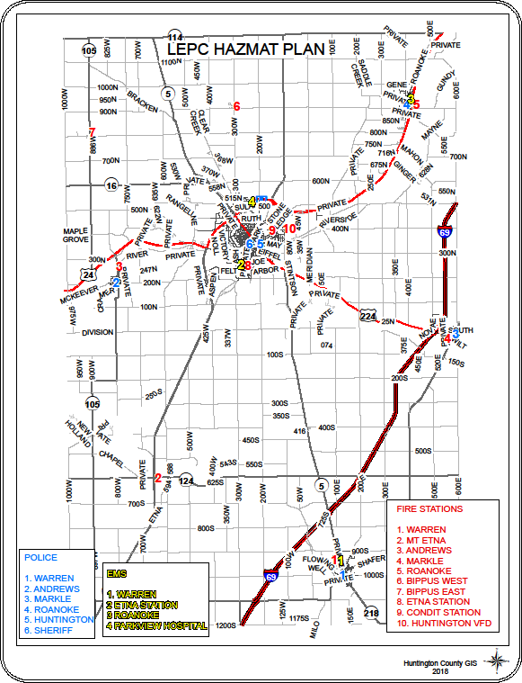

TAB 3 - TRANSPORTATION, RAILROAD, AND PIPELINE ROUTES

PIPELINES
Buckeye Partners, L.P. Kaneb Pipe Line Operating Partnership, L.P. (Valero, L.P.)
4527 N. Meridian Road 7340 W 21st Street N., Suite 200
Huntington IN 46750 Wichita KS 67205
(260) 356-5802 IL HQ (636) 399-2456 (316) 617-773-9000 Cell (316) 722-3407
Railroads
*Norfolk Southern Corporation Three Commercial Place Norfolk, VA 23510-9227
(800)-453-2530/(800) 272-0911
*For non-emergency Hazardous Materials information during normal business hours (540) 981-4645 or 3762
Roadways
Interstate 69 ( I-69) | US 24
State Road 9 | State Road 16
State Road 105 | State Road 114
State Road 124 | State Road 218
State Road 5
Rivers
Wabash River | Little River
Salamonie River

HIGHWAY TRANSPORTATION SYSTEM HUNTINGTON COUNTY

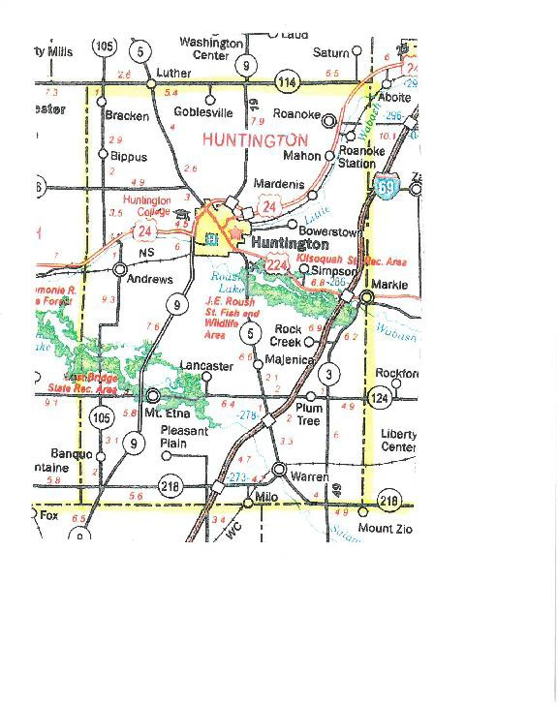

PIPELINES – PETROLEUM AND OTHER

BUCKEYE PARTNERS
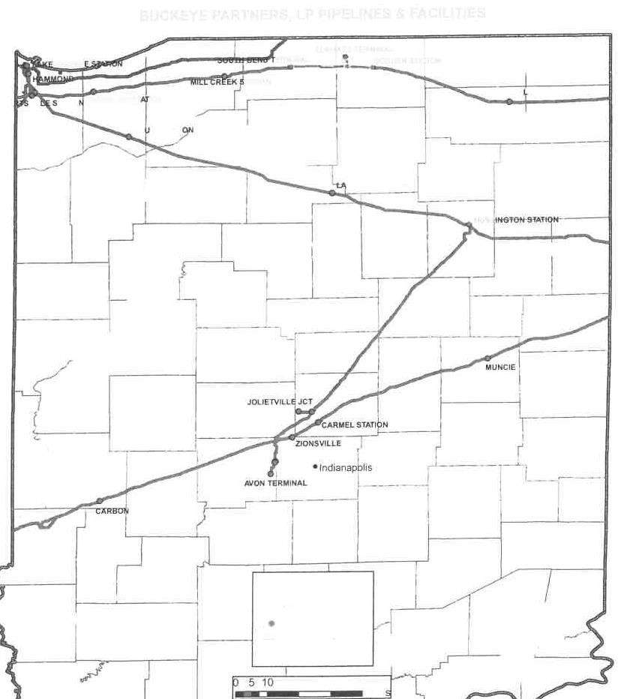

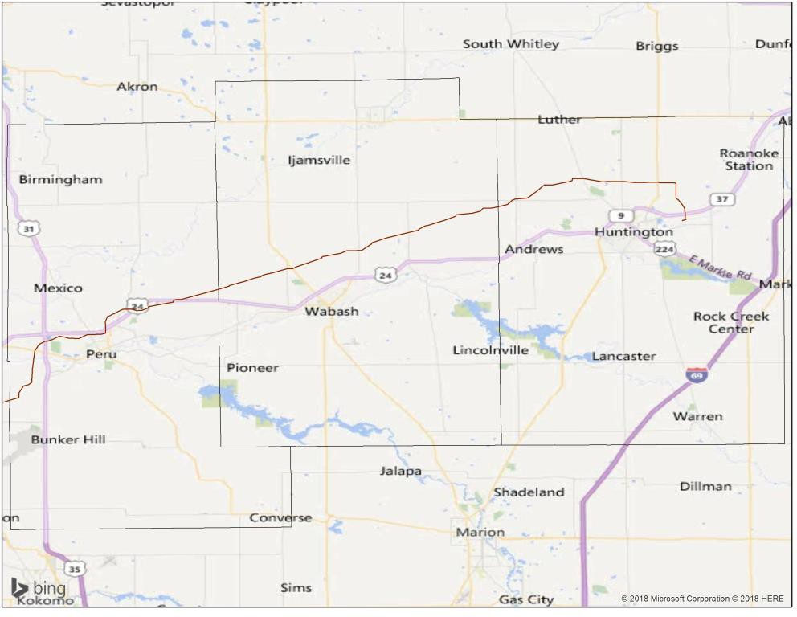
NUSTAR AMMONIA PIPELINE

RAILROADS (EAST-WEST)

City of Huntington
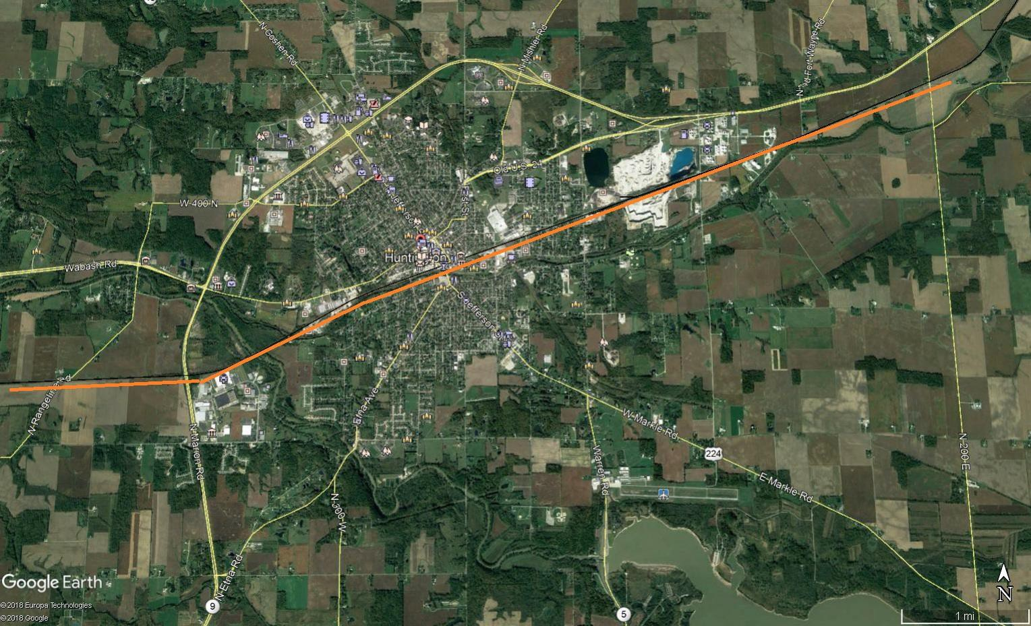

= Railroad

Town of Andrews
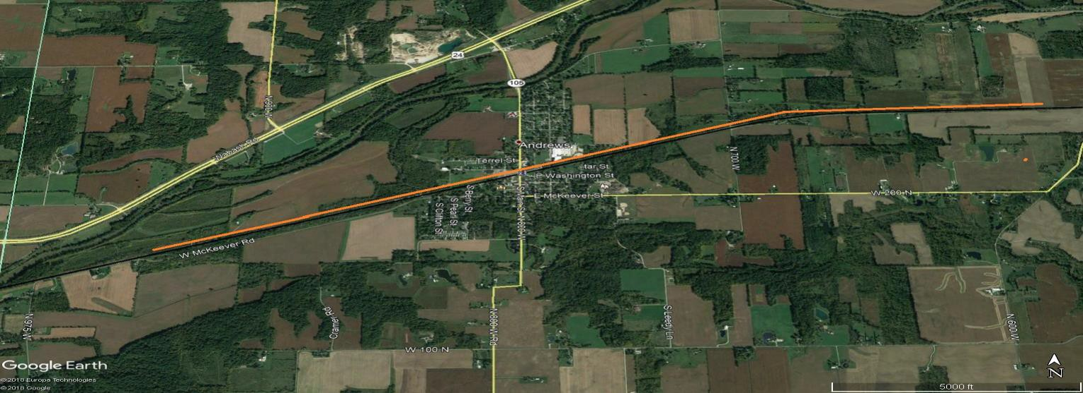
= RAILROAD

RAILROADS (EAST-WEST)

Town of Roanoke
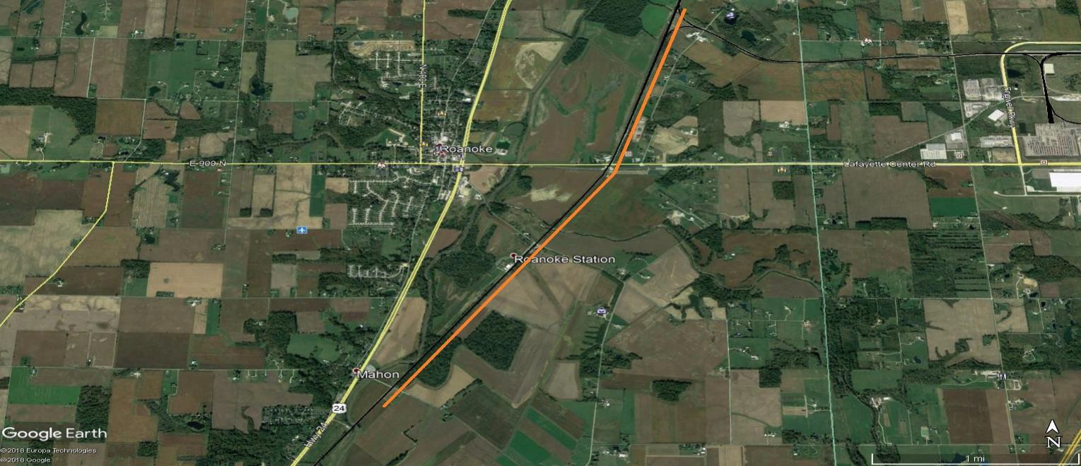
= Railroad

Huntington County
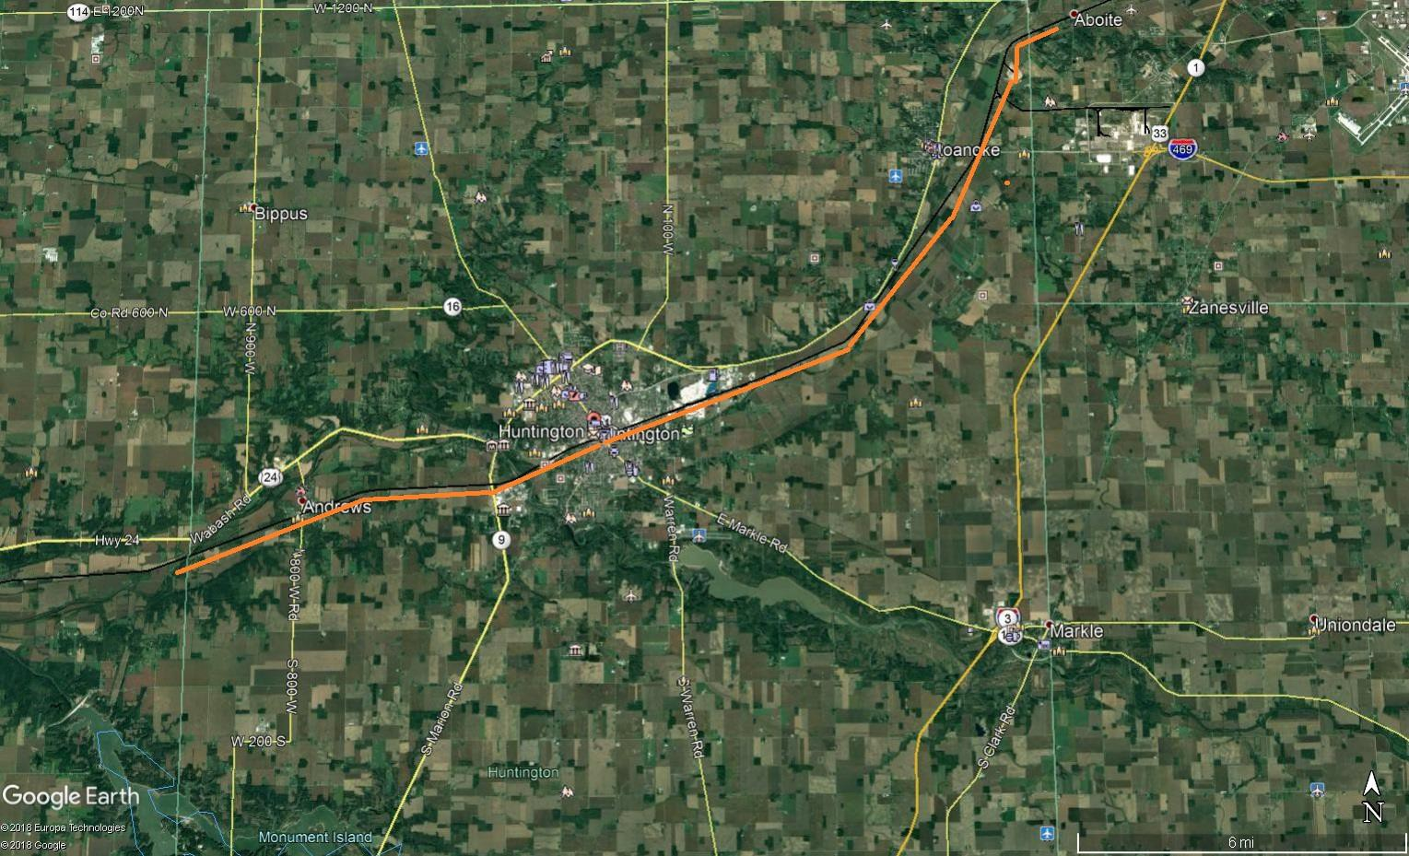

= Railroad

TAB 4 - EHS Fixed Facilities
Vulnerability Zones and Evacuation Routes

EHS FACILITIES

A T & T Andrews
Bendix Commercial Vehicle Systems 13639
Bendix Commercial Vehicle Systems 29585
Bendix Commercial Vehicle Systems 30745
Bendix Commercial Vehicle Systems 34488
Bendix Commercial Vehicle Systems 113686
Bendix Distribution Facility 114401
Ceres Solutions Cooperative 13931
Ceres Solutions Cooperative 100013
Continental Structural Plastics
CF Industries Sales LLC
Crop Production Services
Echo Lake Foods Inc
Ecolab Inc 112714
Ecolab Inc 11681
Frontier Communications 12870
Frontier Communications 10893
Gladieux Trading & Marketing
Ground Effects LLC
Helena Chemical Company
Huntington Sheet Metal Inc
City of Huntington – South Water Plant
City of Huntington WPC
Indiana Michigan Power
Koch Fertilizer LLC
Our Sunday Visitor Inc
Schenkel’s All Star Dairy Inc (Dean Foods)
Schneider Electric Huntington
United Technologies Electronic Controls

AT&T (ANDREWS)
50 JEFFERSON STREET, ANDREWS, INDIANA 46702
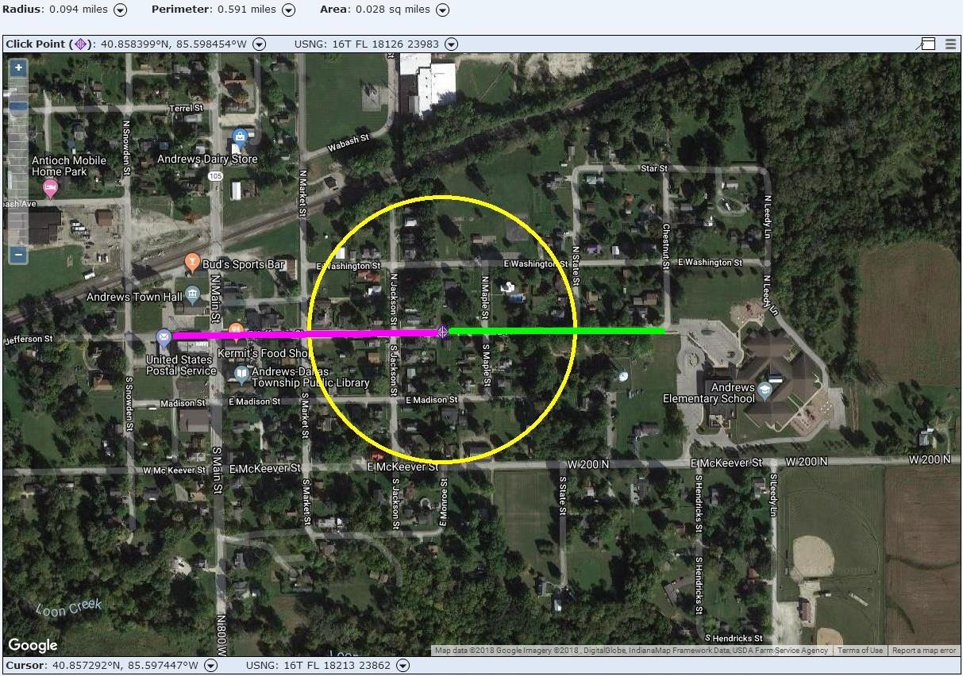

GREEN = Suggested Primary Evacuation Route Affected Population: 85
MAGENTA = Suggested Secondary Evacuation Route

500 ft. Maximum Vulnerability Area For: SULFURIC ACID (Batteries)

POTENTIAL AFFECTED AGENCIES
None

BENDIX COMMERCIAL VEHICLE SYSTEMS (113686)
1600 RIVERFORK DR. HUNTINGTON, INDIANA 46750

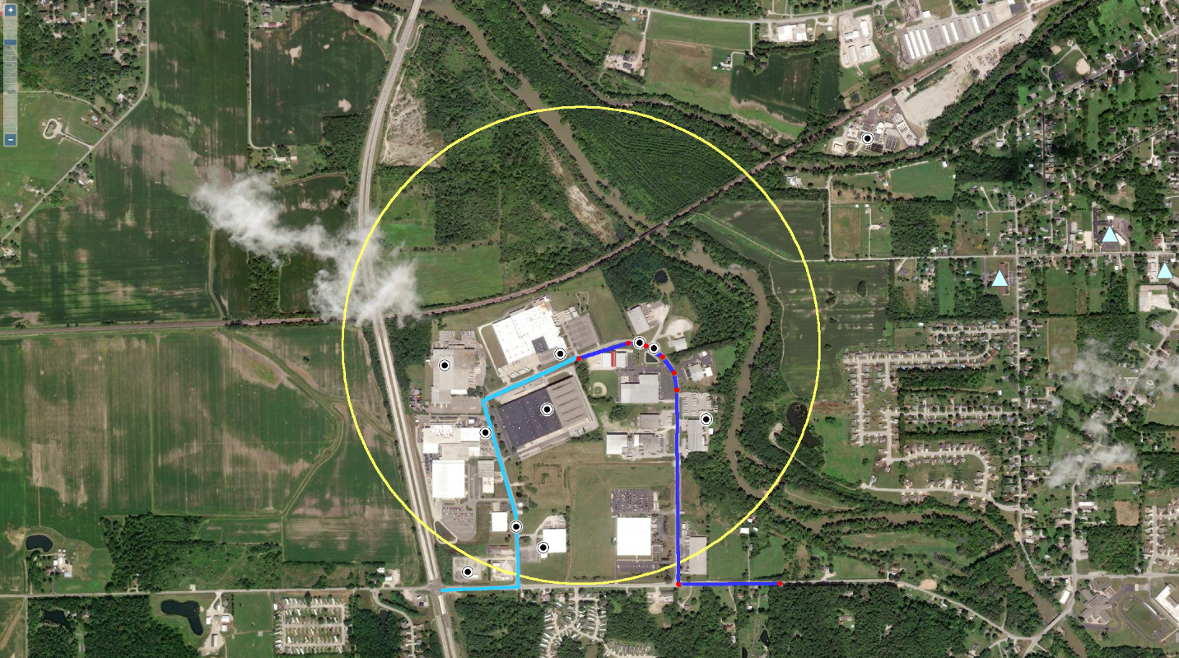

Light Blue = Suggested Primary Evacuation Route Affected Population: zero
Dark Blue= Suggested Secondary Evacuation Route

2,640 ft. Maximum Vulnerability Area for: SULFURIC ACID

POTENTIAL AFFECTED AGENCIES

BENDIX COMMERCIAL VEHICLE SYSTEMS (114401)
1515 RIVERFORK DR. HUNTINGTON, INDIANA 46750

Light Blue = Suggested Primary Evacuation Route Affected Population: zero
Dark Blue= Suggested Secondary Evacuation Route

2,640 ft. Maximum Vulnerability Area for: SULFURIC ACID

POTENTIAL AFFECTED AGENCIES

BENDIX COMMERCIAL VEHICLE SYSTEMS (29585)
1230 SABINE STREET, HUNTINGTON, INDIANA 46750
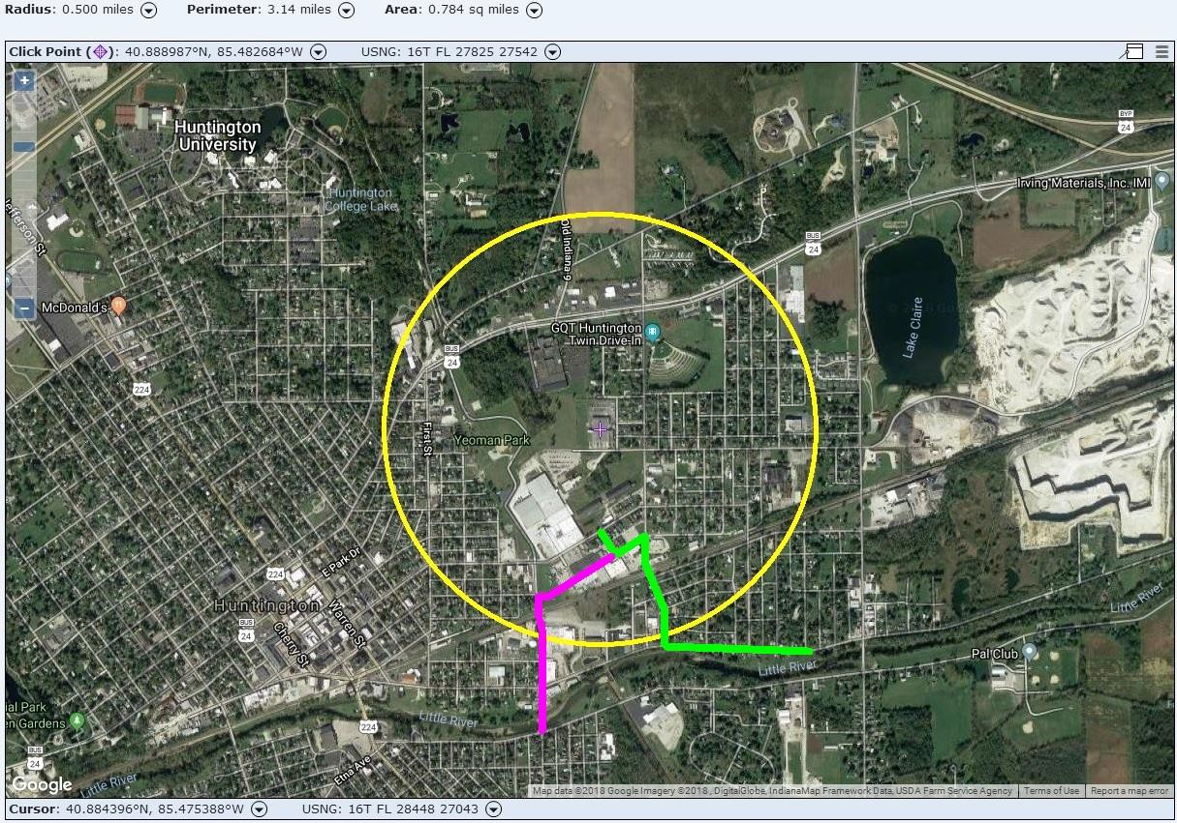

GREEN = Suggested Primary Evacuation Route Affected Population: 1,765
MAGENTA = Suggested Secondary Evacuation Route

2,640 ft. Maximum Vulnerability Area For: SULFURIC ACID

POTENTIAL AFFECTED AGENCIES
None

BENDIX COMMERCIAL VEHICLE SYSTEMS (30745)
2051 RIVERFORK DRIVE, HUNTINGTON, INDIANA 46750
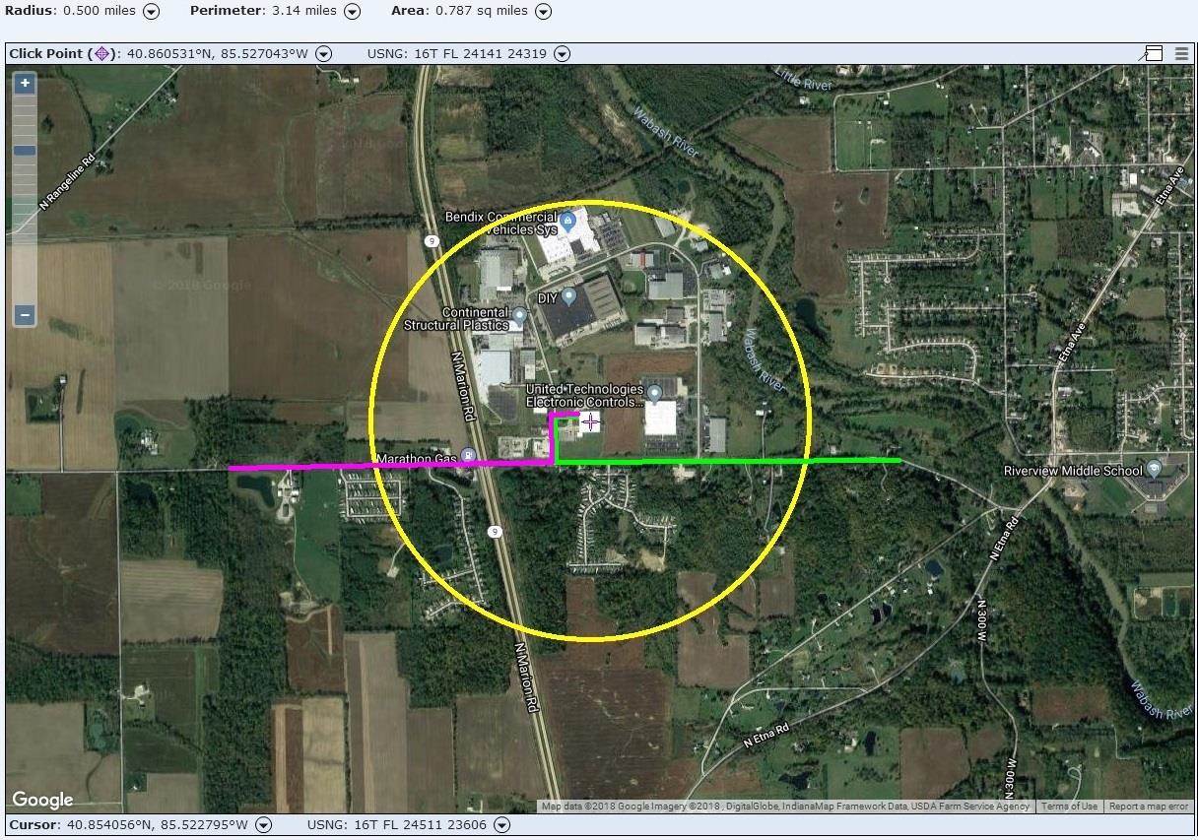

GREEN = Suggested Primary Evacuation Route Affected Population: 248
MAGENTA = Suggested Secondary Evacuation Route

2,640 ft. Maximum Vulnerability Area For: SULFURIC ACID

POTENTIAL AFFECTED AGENCIES
None

BENDIX COMMERCIAL VEHICLE SYSTEMS (34488)
1155 EAST FRANKLIN STREET, HUNTINGTON, INDIANA 46750
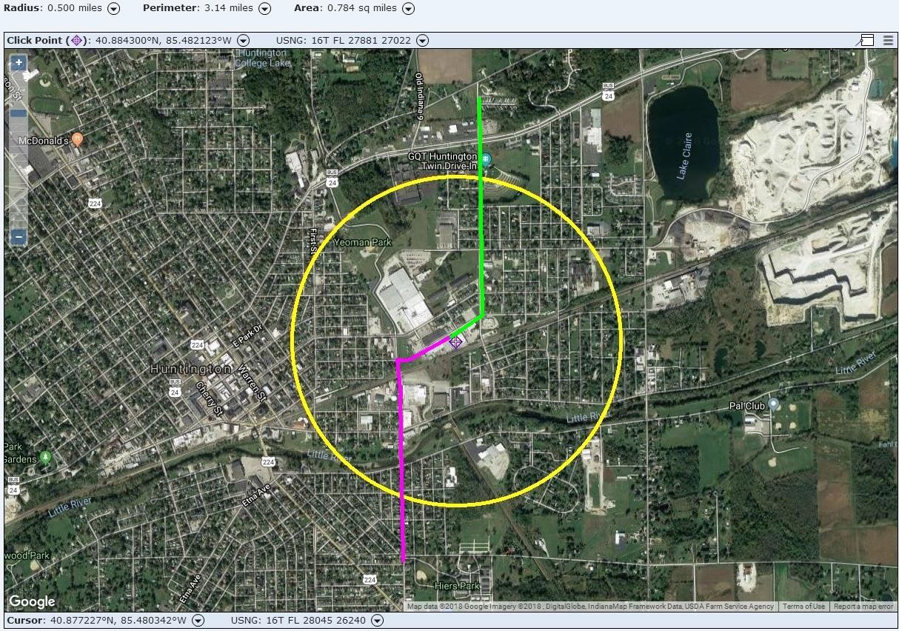

GREEN = Suggested Primary Evacuation Route Affected Population: 2,249
MAGENTA = Suggested Secondary Evacuation Route

2,640 ft. Maximum Vulnerability Area For: SULFURIC ACID

POTENTIAL AFFECTED AGENCIES

BENDIX COMMERCIAL VEHICLE SYSTEMS (13639)
1850 RIVERFORK DRIVE, HUNTINGTON, INDIANA 46750
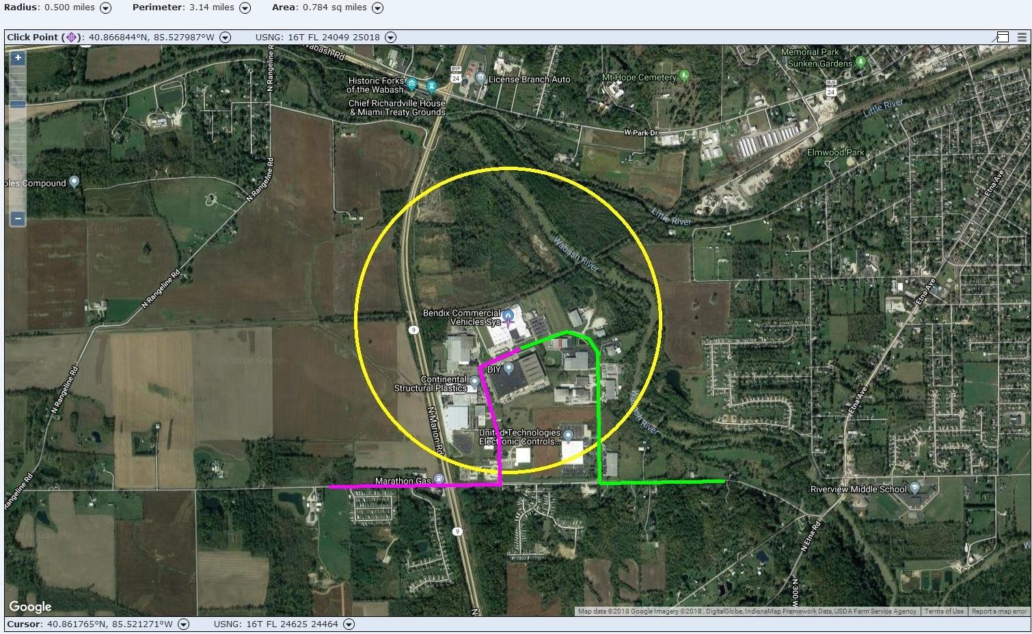

GREEN = Suggested Primary Evacuation Route Affected Population: 0
MAGENTA = Suggested Secondary Evacuation Route

2,640 ft. Maximum Vulnerability Area For: SULFURIC ACID

POTENTIAL AGENCIES AFFECTED
None

